

North South University
Department of Electrical & Computer Engineering

LAB REPORT
Course Code: EEE141L
Course Title: Electrical Circuits-I Lab
Faculty Name: Dr. Aynal Haque (AyL)
Experiment Number: 01
Experiment Name:
Ohm’s Law

Experiment Date: 29 / 01 / 2026
Date of Submission: 05 / 02 / 2026
Section: 17
Group Number: 05
Submitted To: Shitangshu Sakhar Halder
Submitted By: Naziba Ali (ID: 2513566642) | Score:

Objectives:

- Find the resistance of a resistor from its color code
- Measure voltage, current and resistance values using a digital multimeter.
- Verify the validity of Ohm’s Law.

Apparatus List:

Components | Value | Amount
Bread Board |  | 1
Resistors | (4.7 k Ω)  (10 k Ω) | 1  1
Digital Multimeter (DMM) |  | 1
Connecting Wire |  | 2

Circuit Diagram:

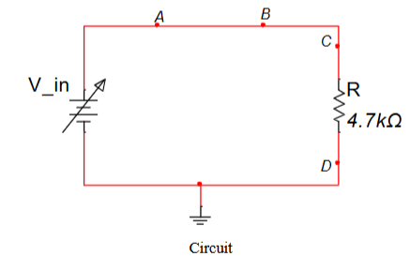

Data Table:

Table 1:
Resistance using color coding |  |  |  |  | Resistance using DMM | %Error
Band 1 | Band 2 | Band 3 | Band 4 | Resistance tol ±
Yellow (4) | Violet (7) | Red (2) | 5% | 4.75 , 4.65 | 4.66 | 0.72%
Brown (1) | Black (0) | Orange (3) | 5% | 10.05 , 9.95 | 9.93 | 0.70%

Table 2:
Experimental reading for 4.7 kΩ
4.7 kΩ  Voltage | Experimental Readings
 | Current I (mA) | Voltage IR (V) | Power $I^{2}$R (mW)
2 | 0.43 | 2.05 | 0.86
4 | 0.87 | 4.08 | 3.53
6 | 1.30 | 6.03 | 7.88
8 | 1.71 | 8.07 | 13..63
10 | 2.15 | 10.01 | 21.54

Table 3:
Experimental reading for 10 kΩ :
10 kΩ  Voltage | Experimental Readings
 | Current I (mA) | Voltage IR (V) | Power $I^{2}$R (mW)
2 | 0.2 | 2.05 | 0.40
4 | 0.4 | 4.03 | 1.59
6 | 0.61 | 6.06 | 3.70
8 | 0.81 | 8.02 | 6.52
10 | 1.01 | 10.1 | 10.13

Stimulation:

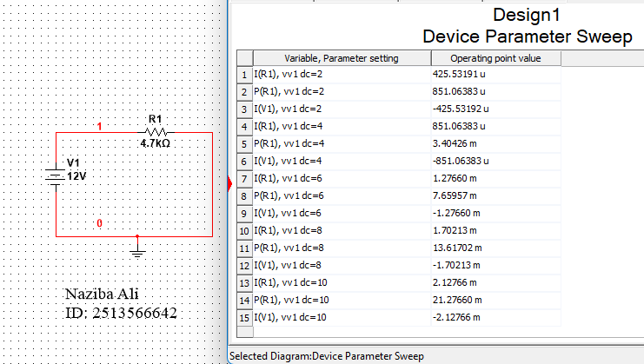

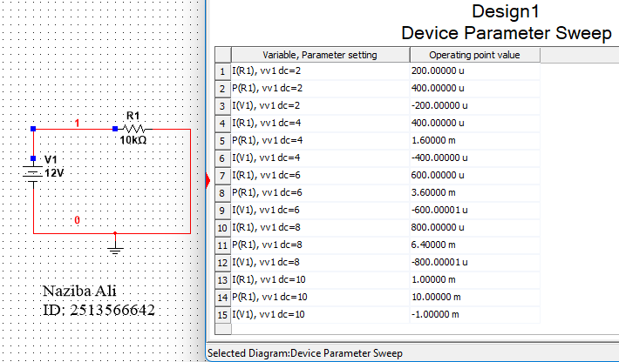

Questions and Answers:

- State Ohm’s law.
Ans: Ohm’s Law states that the current flowing through a conductor is directly proportional to the voltage applied across it, provided the temperature and other physical conditions remain constant.

- How did you identify the resistances of the resistors?
Ans: We initially identified the resistances using the color-coding method printed on the resistors. Then we measured them using a digital multimeter (DMM) to verify the values.

- Calculate the resistance of each circuit using the slope of your V vs I graphs. Compare these R graph values to the measured R values using DMM. Find the percentage difference.
Ans: For slope, $m = (y_{2} - y_{1}) / (x_{2} - x_{1})$

For 4.7 KΩ,  m = (10.01 – 6.03) / (2.15–1.30)  = 4.68 | For 10 KΩ ,  m = (10.1 – 6.06) / (1.01–0.61)  = 10.1
Percentage (%) Difference,
For 4.7 KΩ,  %diff = ((4.68 – 4.66) / 4.66) × 100  = 0.43% | For 10 KΩ,  %diff = ((10.1 – 9.93) / 9.93) × 100  = 1.71%

- Plot V vs I graph for each resistor value in the same graph.
Ans:
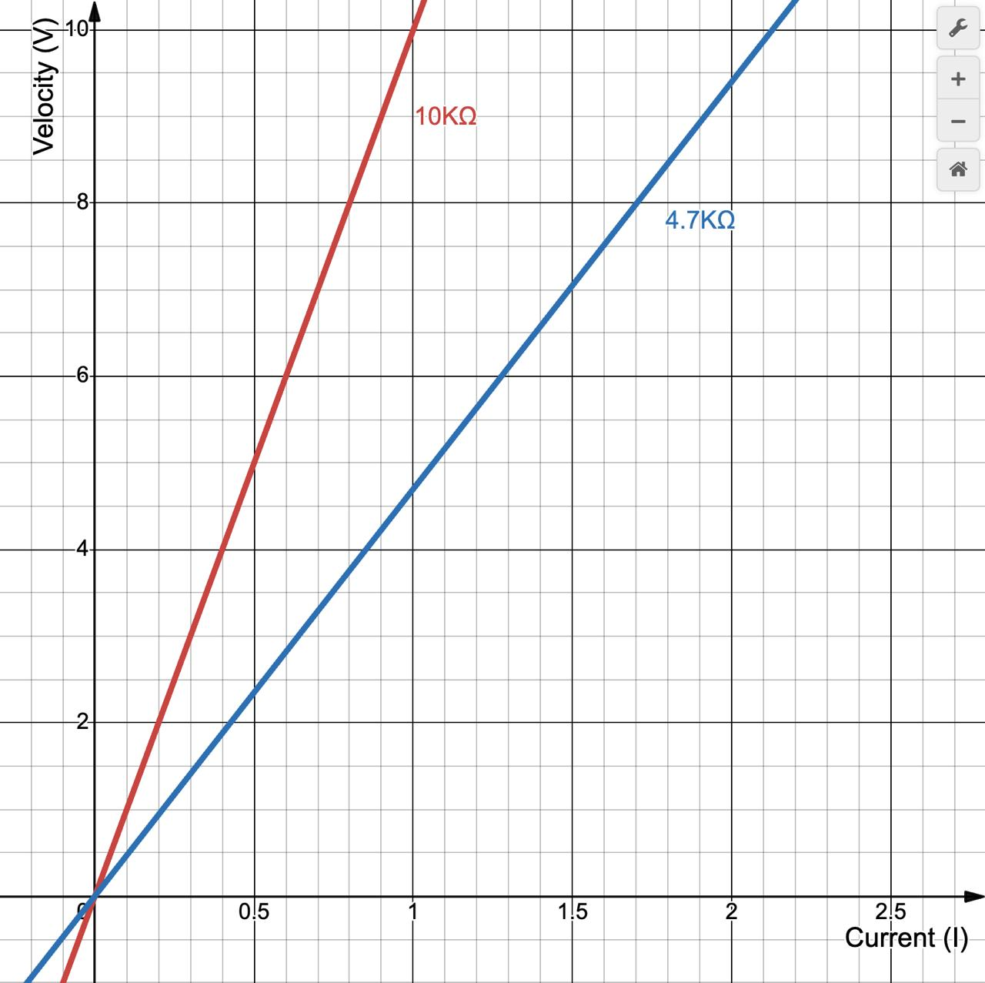
Discussion:
At first, we identified the resistance of the resistance of the resistors using the color-coding technique. Then, when we tried to measure the resistance using DMM. The value was incorrect, like for the 4.7kΩ, it showed around 200Ω. So, we thought the DMM was not working properly. Then we checked with the 10kΩ and it was right. So, we figured the resistor was broken. After we changed it, we got the right values. Even though, the DMM value varied a bit from the actual value, it was due to the resistor’s tolerance.
Then we measured the current by breaking the circuit and connecting the DMM in series. We measured current for increasing voltage and figured out that for increasing voltage, flow of current increases. Thus, proving that this circuit follows Ohm’s law

